# weekly progress report

|  |  |
| --- | --- |
| Tasks | Progress |
| 1.round the score to fit the width of the screen | finished |
| 2.fix the scrollview | finished |
| 3.display corresponding emoji on camera preview | finished |

Task1:

I round the facial expression score to two decimal places. Then phone screen can properly contain and display all data.

**public static double** round(**double** val) {  
 DecimalFormat df2 = **new** DecimalFormat(**"###.######"**);  
 **return** Double.*valueOf*(df2.format(val));  
}

**disappointed** = *round*(face.**emojis**.getDisappointed());*//index 0***flushed** = *round*(face.**emojis**.getFlushed());*//index 1***kissing** = *round*(face.**emojis**.getKissing());*//2***laughing** = *round*(face.**emojis**.getLaughing());*//3***rage** = *round*(face.**emojis**.getRage());*//4***relaxed** = *round*(face.**emojis**.getRelaxed());*//5***scream** = *round*(face.**emojis**.getScream());*//6***smiley** = *round*(face.**emojis**.getSmiley());*//7***smirk** = *round*(face.**emojis**.getSmirk());*//8***stuckOutTongue** = *round*(face.**emojis**.getStuckOutTongue());*//9***sotwinkingEye** = *round*(face.**emojis**.getStuckOutTongueWinkingEye());*//10***wink** = *round*(face.**emojis**.getWink());*//11*

Task2:

I fixed the scroll view in layout file. Then user can scroll the screen smoothly and see all data in a single page.

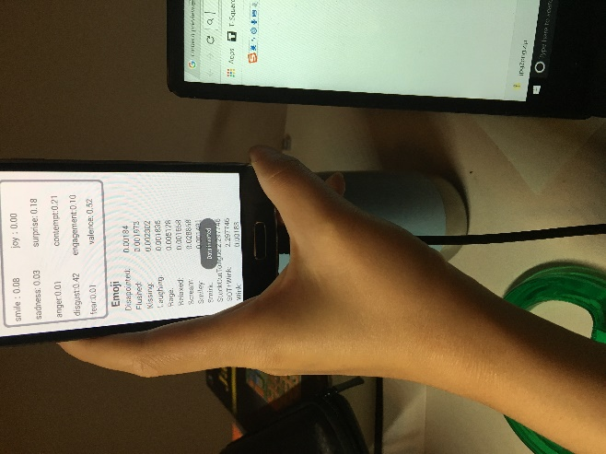

Task3：

I used the image view to display emoji properly. The way that system choose to pick a emoji based on the highest user’s expression score. Which expression has the highest score then program will choose to display this kind of emoji. See sample output below:

